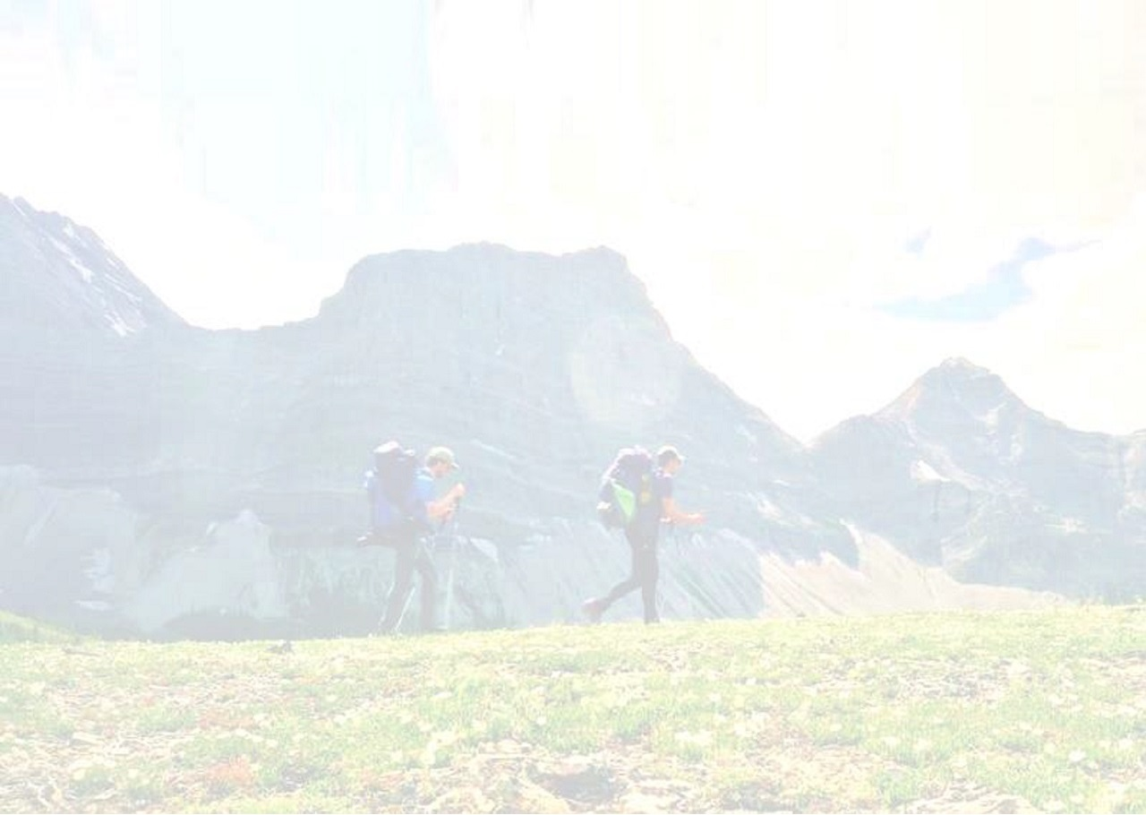

GREAT DIVIDE TRAIL ASSOCIATION
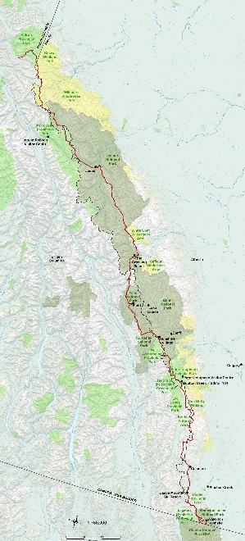
TRAIL FINISHER RECOGNITION

Presented To

Your Name Here

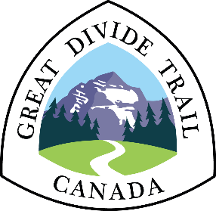
For Completion Of
Canada’s Great Divide Trail
Completion Date Here

